**Project Design Phase-II**

**Technology Stack (Architecture & Stack)**

|  |  |
| --- | --- |
| Date | 14October 2022 |
| Team ID | PNT2022TMID30018 |
| Project Name | Project – IoT Based Smart Crop Protection system for Agriculture |
| Maximum Marks | 4 Marks |

**Technical Architecture:**

The Deliverable shall include the architectural diagram as below and the information as per the table1 & table 2

**Example: Order processing during pandemics for offline mode**

**Reference:** [**https://developer.ibm.com/patterns/ai-powered-backend-system-for-order-processing-during-pandemics/**](https://developer.ibm.com/patterns/ai-powered-backend-system-for-order-processing-during-pandemics/)

Guidelines:

1. Include all the processes (As an application logic / Technology Block)
2. Provide infrastructural demarcation (Local / Cloud)
3. Indicate external interfaces (third party API’s etc.)
4. Indicate Data Storage components / services
5. Indicate interface to machine learning models (if applicable)

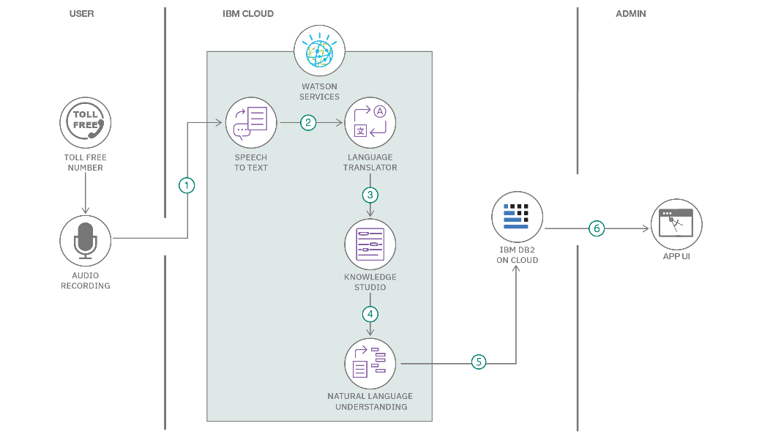

**Table-1 :Components & Technologies:**

|  |  |  |  |
| --- | --- | --- | --- |
| **S.No** | **Component** | **Description** | **Technology** |
|  | PIC microcontroller | Sensing the animals entered in crop field | HTML,CSS,Javascript |
|  | buzzer | Used as loud noise maker | Java/python |
|  | GSM module | For Data transfer applications and  Send sms alert to farmer | IBM Watson STT service |
|  | LCD Display | Provides monitor’s brightness and  Display the presence of animal | IBM Watson Assistant |
|  | LDR | Detect the size of the animal | MySQL,NoSQL |
|  | Flame sensor | Detect the fire when give alert messages to  Farmer | IBM DB2, |
|  | APR board | Used to divert a animal by giving the  Sounds | IBM Block storage |
|  | LASER | Used for general illumination | IBM Weather API |
|  | PIR sensors | Detect the position of the animal | An electronic sensor that measures infrared IR light radiating from objects in its field of view. |
|  | SD card module | Work with negative restricted memory | Solid state storage device |

**Table-2: Application Characteristics:**

| **S.No** | **Characteristics** | **Description** | **Technology** |
| --- | --- | --- | --- |
|  | Open-Source Frameworks | The major problem faced by the Indian farmer is their poorly maintained irrigation.  This system maintained irrigation system properly. | Technology of open-source  Framework |
|  | Security Implementations | It is very important to monitor the ns of animals.  This system provide a better solution to resolve this problem. | E.g. SHA-256,Encryption,IAM controls |
|  | Scalable Architecture | This system yields a monitoring procedure for farm safety against animal attacks. | Technology used |
|  | Availability | The crops are ravaged by the wild animals at night time.  It is not possible to farmers to barricade entire fields and guard it. | Technology used |
|  | Performance | Microcontroller sensing the animals and send the alert messages to farmer. | Technology used |

**References:**

[**www.wikipedia.com**](http://www.wikipedia.com)

[**https://www.arduino.cc**](https://www.arduino.cc)

**https://en.m.wikipedia.org>wiki>arduino**